Physics 20 Lesson 29 Waves in One Dimension

Due to its nature, wave energy is incredibly difficult to describe in words because waves involve dynamic motion through space. In an effort to clarify the concepts and ideas associated with waves you will find several **video clips** that are found in the content area of the D2L site. The clips are short and they help you to visualise what is being talked about in the lesson. You may also wish to refer to pages 392 to 415 in Pearson for a discussion of the properties of waves.

# Mechanical waves

There are two basic ways to transmit or move energy from one place to another. First, one can move an object from one location to another via kinetic energy. Second, one can move energy in the form of waves. **Waves are energy carriers, moving energy through distances as a result of vibratory motions**. Examples of waves are seen or heard around us every day; ripples on water, sound, sunlight, etc. There are two general classes of waves: electromagnetic waves and mechanical waves.

**Electromagnetic****waves** (also known as **light**) are capable of moving through objects or through the vacuum of space. We will study electromagnetic waves and light in Physics 30.

**Mechanical waves**, on the other hand, require a **medium** of some kind (i.e. - air, water, a string, a spring, metals, rocks, etc.) through which they can travel. Mechanical waves cannot travel through a vacuum since there is no substance available to support and maintain the wave energy. There are two types or classes of mechanical waves: **transverse** waves and **longitudinal** waves.

# L24 P03Transverse Waves

For a transverse wave the particles in the medium vibrate perpendicular to the direction of motion of the wave energy. A transverse wave has crests (positive amplitude) and troughs (negative amplitude) as shown in the diagram below. Grab a snaky and experience producing transverse wave pulses.

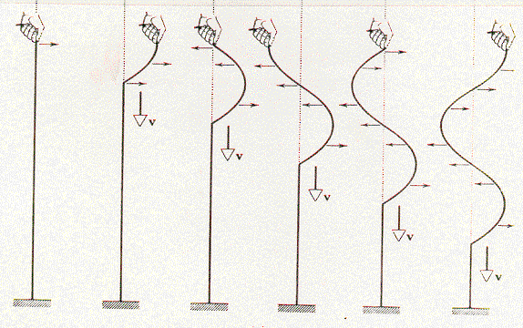

Check out the video clip called P20 L29 Creating a Transverse Wave on D2L.

# Longitudinal Waves

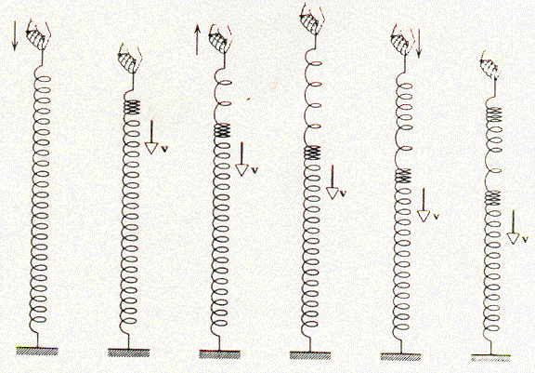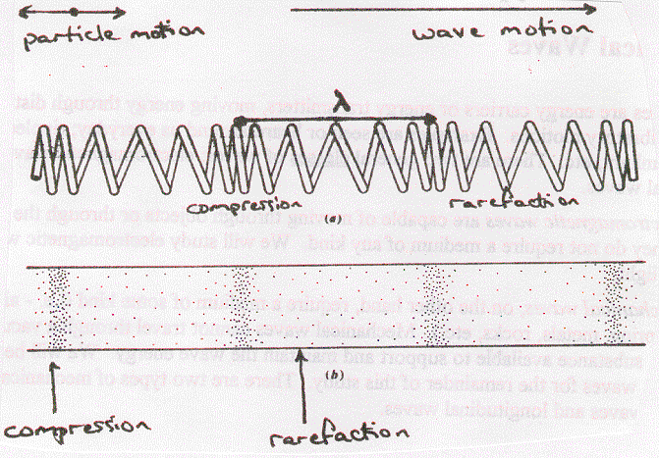For **longitudinal** waves (also called **compression** waves and **pressure** waves) the particles in the medium vibrate parallel to the direction of motion of the wave energy. The wave travels by causing instantaneous compressions and rarefactions in the medium. A **compression** is a region where the particles are instantaneously more highly concentrated and a **rarefaction** is a region where the particles are instantaneously further apart. Of course, once the wave passes through a given region, there is no trace of the wave left behind. Grab a snaky and experience producing longitudinal wave pulses.

Check out the video clips called P20 L29 Creating a Longitudinal Wave and P20 L29 Transverse and Longitudinal Waves on D2L.

# Wave pulses and waves

A **wave pulse** is a disturbance that has a beginning and an end. You made a wave pulse when you moved your hand back and forth once in the snaky activity. The word **wave** or **wave train** is usually reserved for a continuous series of pulses. You made a wave by moving your hand back and forth repeatedly. The **amplitude** of a wave pulse or a wave is the maximum displacement of the medium from the equilibrium position. The following diagrams illustrate the difference between a wave and a wave pulse, and the amplitude (A) is shown on each.

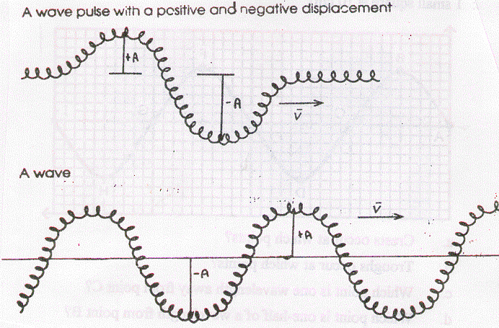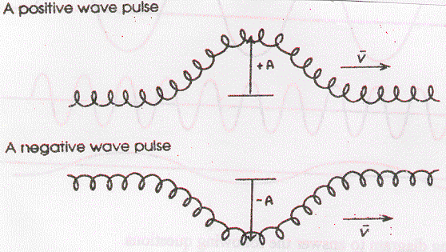

# Wavelength, period and frequency

For any type or class of wave, the **wavelength** ( - pronounced “lam-da”) of a wave is equal to the distance (unit is metres) between two points which are in the exact same phase or position on the wave.

amplitude



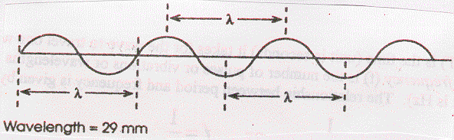

Use a ruler to double-check the diagrams. Do each of the measurements at different locations on the wave give the same result? The wavelengths of the waves in the diagrams are nearly identical, but the waves have different amplitudes.

The **period** (T) is the time it takes for the wave to travel one wavelength of distance, and the **frequency** (f) is the number of pulses or vibrations or wavelengths which occur in one second. The unit for period is usually seconds and the unit for frequency is Hertz (Hz). As we saw in circular motion, the relationship between period and frequency is given by:



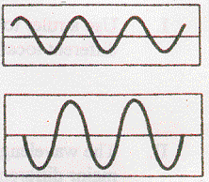

Notice that wavelength, period and frequency **do not depend** on the **amplitude** of the wave. To demonstrate this, consider the pair of waves to the right. Both waves have the same wavelength and frequency, but their amplitudes are different. The top wave has half the amplitude of the bottom wave. Amplitude is related to the energy of the wave – the greater the amplitude, the greater the energy. Frequency, on the other hand, is related to the vibratory rate of the source of the wave – the higher the vibratory rate, the higher the frequency.

# Speed and the Universal Wave Equation

All waves move through different materials or media (plural for medium) with different certain speed. The magnitude of the speed will depend on a number of factors. For instance, sound waves travel through rocks faster than they travel through air since the rock has a greater density than air. Another factor is rigidity; the more rigid the medium, the faster the speed of a wave in that medium. For all waves, there is a simple relation between speed, frequency and wavelength.

From our previous work we know that speed is given by:



For a wave the distance travelled in one cycle is one wavelength (d =  and the time required for one cycle is the period (t = T = 1/f). Thus:



This is called the **Universal Wave Equation** because it applies to **all** kinds of waves.

A series of waves with a wavelength of 2.5 m have a frequency of 50 Hz. What is the speed if the wave series?

v = f  = 50 Hz x 2.5 m = **125 m/s**

A wave series with a wavelength of 10 m has a speed of 300 m/s. What is the frequency of the waves?

 **30 Hz**

# Reflection and transmission of waves

When a wave or a pulse on a string or rope meets a boundary of some kind, some or all of the wave energy will be **reflected** by the boundary. The manner in which the wave is reflected depends on the nature of the boundary.

If the boundary is a **fixed end**, the reflected pulse will be inverted relative to the incident pulse.

The reflection of a pulse on a string with a fixed end point: As the pulse arrives, it exerts a vertical force on the fixed anchor point, which in turn exerts an equal and opposite force on the string. When the string tugs up, the anchor point tugs down. This downward force on the string generates an upside-down (inverted) reflected pulse.

Check out the video clip called P20 L29 Wave Reflection Fixed end on D2L.

If the boundary involves a **free end**, the reflected pulse will be upright relative to the incident pulse.

The reflection of a pulse on a string with a free end point: The free end rises until all of the energy of the pulse is stored elastically. It comes to rest at a maximum vertical displacement of twice the height of the crest. Carried by its own inertia the end segment pulls upward on the string, generating a reflected pulse that is right side up.

Check out the video clip called P20 L29 Wave Reflection Free end on D2L.

When a wave pulse moves from one rope to another, some of the wave energy is reflected (**partial reflection**) and some is **transmitted** into the next rope. In the examples below, note that the transmitted wave is upright in both cases. However, the orientation of the reflected wave depends on the difference in speed between the two media. For slow to fast reflection, the reflected pulse is upright. For fast to slow reflection, the reflected pulse is inverted. Note that the amplitude of the incident pulse is divided into two smaller amplitudes for the reflected and transmitted pulses.

slow

fast

Note: Due to the universal wave equation, the wavelength of the pulse in the faster medium is longer than the wavelength in the slower medium.

fast

slow

# Interference

When two waves moving in opposite directions meet they do not reflect off each other, rather *they pass through one another*. As they do so, the waves superimpose and **interfere** with each other creating a temporary waveform that is the *sum* of the two waves. Thus if the waves meet *in phase* (crest to crest and trough to trough) then the sum of the amplitudes of the waves produces a larger waveform. This is called *constructive interference*. On the other hand, if the waves meet *out of phase* (crest to trough and trough to crest), the sum of the amplitudes tends to cancel each other out resulting in *destructive interference*. The idea of adding the waves together is called the **principle of superposition**. Check out the video clips called P20 L29 Wave Interference and P20 L29 Constructive Interference on D2L.

Constructive interference:

reference point

Destructive interference:

# Summary

This lesson has focussed on one-dimensional waves on a wire, string or rope. The various types (transverse, longitudinal) and properties (reflection, transmission, interference) of waves and the universal wave equation that were introduced in this lesson also apply to all kinds of waves in two-dimensional and three-dimensional space. We learn about two-dimensional wave phenomena in the next lesson.

Waves on a Snaky Activity

**Purpose**:

To investigate the properties of waves using a snaky as a model.

**Materials**: long coil spring (snaky)

***\*NOTE* snakys are not social. Do not allow the snakys to become tangled together! Store each one in its own box or container!***

***Snakys are also quite delicate and sensitive. Do not stretch them too far.***

**Procedure**:

1. Working with a partner, you will need a clear path of about 6 m for this activity.

2. Slowly stretch the snaky. Do not stretch it too far length since this will cause permanent damage.

3. Grip the snaky firmly with one hand for the entire activity with one person on each end.

4. It is easier to see the motion of the snaky if you are near one end. Don't watch from the side.

5. As the pulses die out, they can still be felt. (Luke, trust your feelings! Let go Luke!)

6. This activity is a sensual experience. Each student should spend some time on the end of a snaky.

7. Try two types of motion to create waves:

A. Pluck the snaky sideways to produce a *transverse* pulse.

B. Pluck the snaky in a parallel motion to produce a *pressure* (longitudinal) pulse.

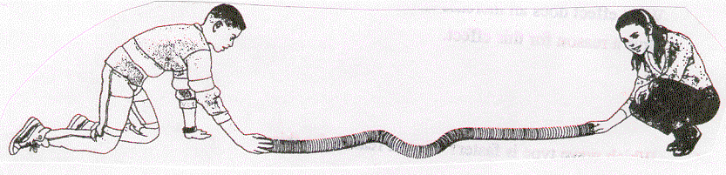8. Look closely at the questions in the *Observations and Analysis* section. Conduct experiments to answer each question.

**Observations and Analysis**:

Answer questions 1 to 7 for both *transverse* and *pressure* wave pulses.

1. What happens to

- the amplitude of a wave as it travels?

- the speed of a wave as it travels?

2. Does the speed depend on the amplitude? (i.e. - as the amplitude changes does the wave travel any slower or faster?)

3. Do pulses moving in the opposite direction bounce off each other or pass through one another?

4. What effect does an increase in spring tension have on the wave pulses? Give a reason for this effect.

5. Which wave type is faster? Give a reason for this.

# Hand-in Assignment

1. Determine the wavelengths of the following waves by measuring with a ruler. Check your answers by measuring the wavelength at different locations.

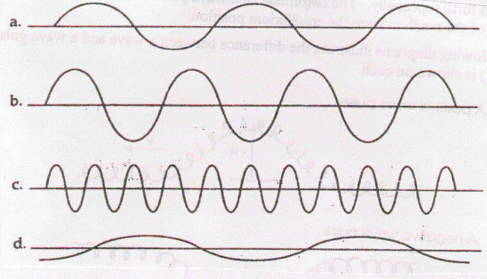

2. Use the following diagram to answer the following questions.

(Scale: 1 small square = 10 cm)

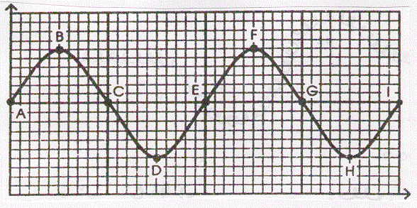

a. Crests occur at which points?

b. Troughs occur at which points?

c. Which point is one wavelength away from point C?

d. Which point is one-half of a wavelength from point B?

e. What is the wavelength?

f. What is the amplitude?

g. If the frequency is equal to 40 Hz, what is the speed of the wave?

3. What is a wave?

4. Draw a transverse wave. Label the wavelength, crest, trough and equilibrium line.

5. Sketch a negative wave pulse of amplitude 2.5 cm. If it is imagined to be travelling from right to left, mark on your diagram the direction of motion of the particles of the medium at the leading and trailing edges of the pulse.

6. What happens to the energy associated with a wave after the wave has been damped out?

7. Sketch a longitudinal wave including wavelength, compressions and rarefactions.

8. For each of the following examples of periodic motion, determine the period and frequency.

a. a metronome clicks 50 times in 15 s

b. a patient breathes 18 times in 30 s

c. a flywheel makes 300 revolutions in one minute

d. a cricket chirps 30 times in 15 s

9. People can actually use their bodies as particles in a medium to form a wave. In each of the diagrams, determine if the wave is transverse or longitudinal and label the appropriate parts.

a. Fans do the wave at a football game.

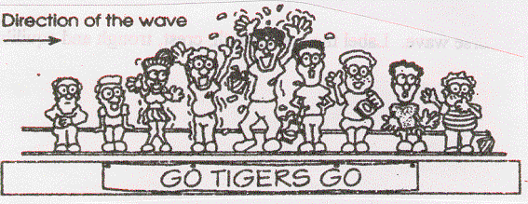

b. People push in the line for football tickets.

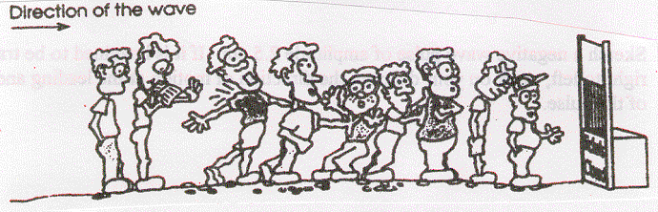

10. Match the following terms to the appropriate phrase:

____ Period a. the motion of a pendulum

____ Frequency b. an S shape on its side

____ Amplitude c. number of vibrations per second

____ Displacement d. the completion of one cycle

____ Sine Curve e. the location of an object

____ Vibration f. time to complete one vibration

____ Simple Harmonic Motion g. position of maximum displacement

11. A meter stick is held vertically behind an object on a spring. The object vibrates from the 20 cm mark to the 32 cm mark on the stick. Find:

a. the equilibrium position

b. the amplitude

c. the displacement when the object is at the 20 cm mark, 24 cm mark, 26 cm mark, and 30 cm mark.

12. The crest of a wave in a ripple tank travels 60 cm in 2.0 s. If the distance between crests is 0.50 cm, what is the frequency of the wave? (60 Hz)

13. The wave generator in a ripple tank produces circular wave patterns at a frequency of 6.0 Hz. A student measures the distance on the floor between troughs of the 3rd and 8th waves to be 7.5 cm. What is the speed of the wave? (9.0 cm/s)

14. Radio telescopes receive waves from distant stars. If such a wave has a wavelength of 21 cm and travels at the speed of light (c = 3.00 x 108 m/s), what is the frequency? (1.43 x 109 Hz)

15. A tuning fork that vibrates at 256 Hz produces a sound wave that is 130 cm long.

a. What is the speed of sound in air? (332.8 m/s)

b. A sound wave in a steel rail has a period of 1.613 x 10-3 s and a wavelength of 10.5 m. What is the speed of sound in steel? (6510 m/s)

c. Two men are standing beside a railway line and they are 500 m apart. If one man strikes the rail with a hammer how long does it take for the other man:

i. to see the hammer hit the rail? (1.76 x 10-6 s)

ii. to hear the sound from the rail line? (7.68 x 10-2 s)

iii. to hear the sound in the air? (1.50 s)

16. Using the terms *frequency*, *wavelength* and *speed*, fill in the blanks:

__________ and ____________ are determined by properties of the medium, while ____________ is determined by the source of the wave.

17. A wave in a coiled spring travels at 10 cm/s.

a. If the frequency of the wave is 2 Hz, what is the wavelength? (5.0 cm)

b. If the frequency of the wave is doubled to 4 Hz does the wave speed change?

c. What would occur if the frequency were reduced to 1 Hz?

18. The human ear can hear frequencies ranging from 20 Hz to 20000 Hz. If the speed of sound in air is 340 m/s, what is the range of wavelengths for audible sound? (17 m, 0.017 m)

19. If the wavelength of a wave is quadrupled and the speed is quartered, what happens to the frequency? (decreased by 16 times)

20. Would you increase or decrease the frequency of a ripple tank generator to produce a wave with a longer wavelength? Explain.

21. The speed and wavelength of deep water waves are 12 cm/s and 1.5 cm respectively. When the water waves enter a shallow region, their speed is reduced to 8.0 cm/s. What is the wavelength in the shallow region? (1.0 cm)

22. The speed and wavelength of shallow water waves are 12 cm/s and 1.5 cm respectively. When the waves enter a deeper region the wavelength increases to 2.0 cm. What is the speed in the deep region? (16 cm/s)

23. A 12 Hz wave travels from deep to shallow water. As it does so, its speed changes from 20 cm/s to 16 cm/s. What are the wavelengths in each region? (1.67 cm, 1.33 cm)

24. In the diagrams below a high speed rope is attached to a low speed chain. Using a diagram and words, explain what happens when (A) a pulse originates on the rope side and (B) when a pulse originates on the chain side.

A.

B.

25. The pulses shown in the following diagrams are moving toward each other. Sketch the shape of the resulting wave pattern at the moment that they directly overlap.